
FIELD REPORT

The CI was introduced to a man known to him as “EL NACHO.” The CI stated that TORRES, Hasdrubal, has offered him the opportunity to work as a driver that can help transport different commercial products between Nogales, AZ, and Nogales, Mexico.
The CI provided a screenshot of a short three-way conversation between “TORRES, Hasdrubal, EL NACHO, and himself. The CI asked TORRES what the WhatsApp message was about and was only told it was about a delivery or an errand that needed to be done.

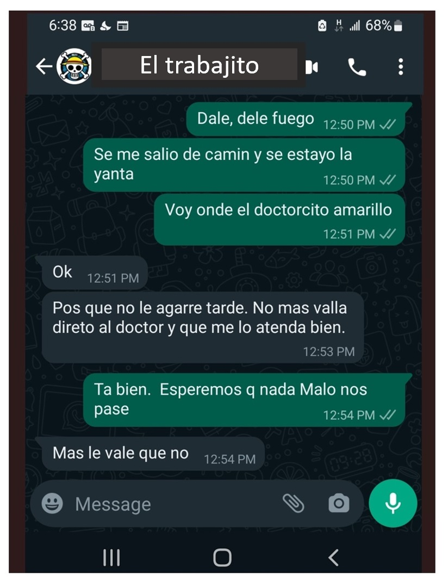
Date of messages April 26^{th,} 2023.

