SAR supporting document.
Internal control number: A-21-08254
Filing date: 21/07/2019
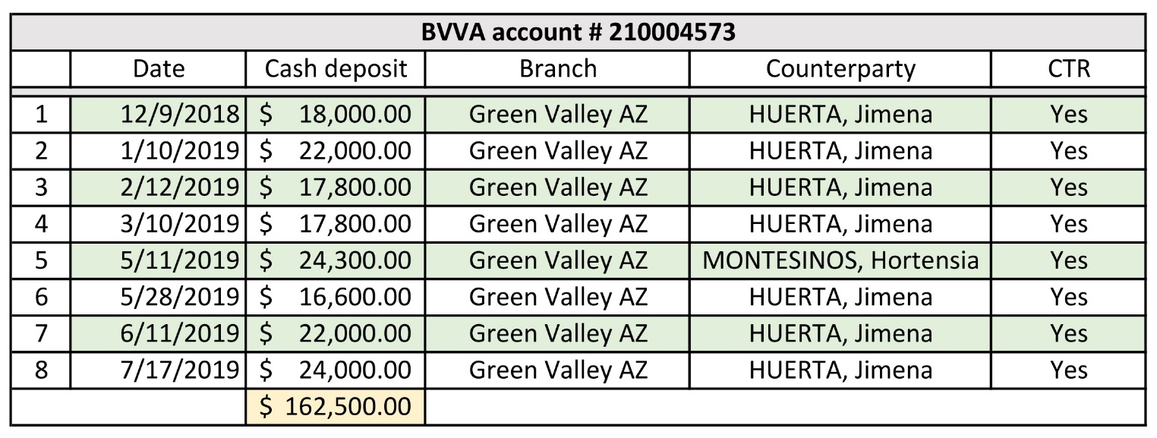
Suspicious cash deposits and CTR summary data.

