
RFI Report
NOGALES PD RFI
Subject: LLANTERA DOC & MONTESINOS, Heriberto
Results:
NPD Detective Sotomayor was contacted to verify if NPD has any information regarding LLANTERA DOC or about its owner, MONTESINOS, Heriberto.
Detective Sotomayor said the tire repair shop had been linked to different suspected perpetrators. Some known local drug dealers frequent the shop. Employee TORRES, Asdrubal, is a suspected drug wholesaler who works for the Sinaloa Cartel and operates out of Nogales, Mexico. TORRES is suspected of facilitating tunnel digging from the American side of the border.
MONTESINOS is the owner of several tire repair shops located throughout Arizona and Mexico.
MONTESINOS has no criminal record. Montesinos lives in Flagstaff, AZ. He is seen frequently in Nogales.
MONTESINOS exports new and used tires into Mexico.
MONTESINOS owns or controls the GONZALES Tire shop located in Nogales, Mexico. (29 Av Los Maestros, Nogales)
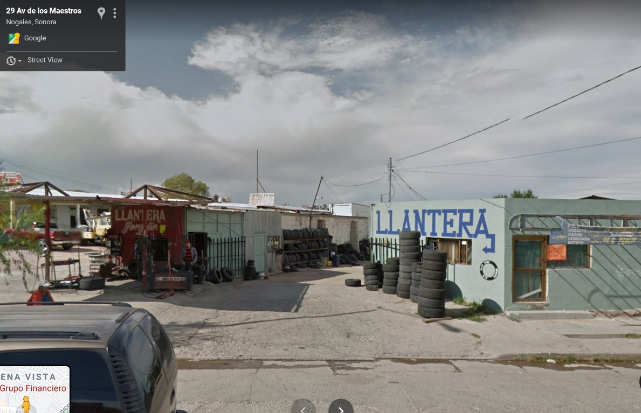
Photo: GONZALES Tire Shop

